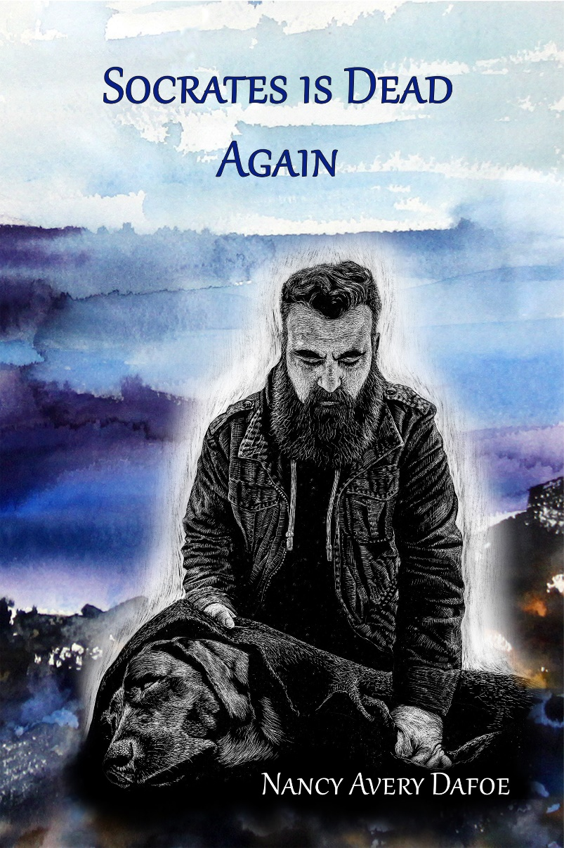

Purchasing details:
Available through Amazon books online; Barnes & Noble online. Novel is 359 pages; 6x9 trade paperback; $15.99 retail; bulk purchase discounts available. Released September 2022 (National League of American Pen Women, Inc., Pen Women Press)
ISBN 978-1-950251-10-0 (print)
LCCN #: 2022911765 (print)

Socrates is Dead Again

“
“Author of twelve published books, Dafoe turns the mirror on her own métier and deftly reveals what it’s like to be a writer. A group of fledgling writers confront the suicide of their hero Adrian Gerd Wahl, a writer’s writer. Wahl’s career stands in stark contrast to these young writers’ quotidian realities. Listening to their voices, we enter into the world of writers . . . Dafoe has written a must-read for those of us consumed with the questions of why we read and why we write.”
Mary Lynch Kennedy, Ph.D.

Book Description: As existential mystery, Socrates is Dead Again concerns a group of young writers’ responses to the suicide of a prominent figure in the literary world, causing them to question their own lives and the meaning of the writing life.

About the Author
Nancy Avery Dafoe, author and educator, has twelve published books in various genres, including memoir, novel, educational texts, and poetry. She lives in Central New York. Her fiction and poetry have won national awards, among other honors.

Contact the author for signed books or speaking engagements: Nancy Avery Dafoe at dafoe.nancy@gmail.com; dafoewritingandconsulting.com; or phone (607) 423-9724

