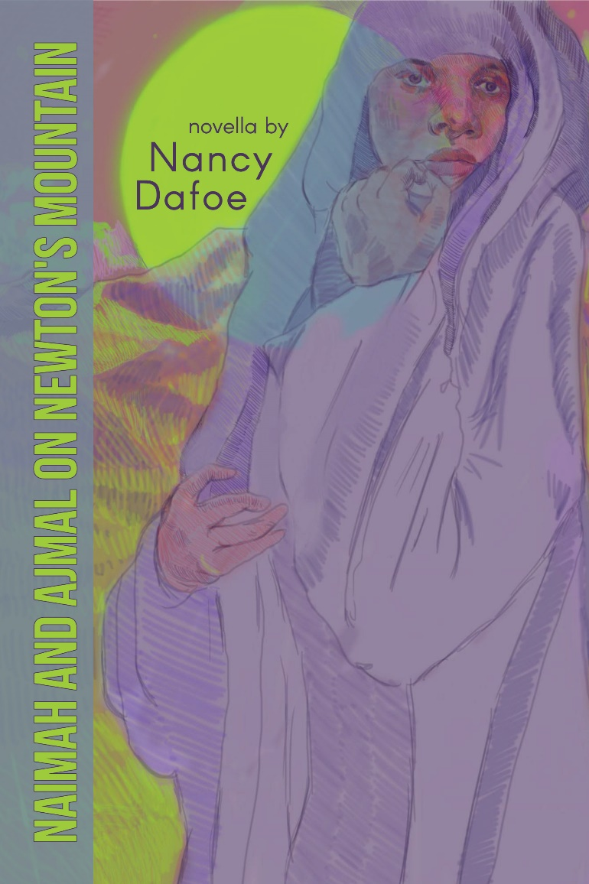
Purchasing details:
Available through the publisher Finishing Line Press (Naimah and Ajmal on Newton’s Mountain by Nancy Dafoe – Finishing Line Press ) and Amazon Books online; Barnes & Noble online; 120 pages; trade paperback and hardcover; $20.99 retail (paperback); bulk purchase discounts. Released 2021
ISBN # 978-1-64662-537-6

Naimah and Ajmal on Newton’s Mountain: A Novella
Wonderful for book clubs on contemporary topic discussions; for students and teachers in cross-curricular and English programs; and for lessons on immigration, the civilian casualties of wars, and contemporary fables.

In her compassionate telling of a heart-breaking (and yet sadly familiar) story — a mother cruelly separated from her child in wartime — Nancy Dafoe challenges readers with a thought experiment about peace, a fable filled with wisdom and insight. The baby, swept away from the violent human world, grows up in a magical realm where spirit creatures teach him through story and song, encouraging him to listen beyond language. We follow the separate journeys of two people with an unbreakable bond: a mother transformed by pain, and a son who never forgets the sound of his mother’s heartbeat.

–Janine DeBaise, author of Body Language

About the Author:

Nancy Avery Dafoe, author and educator, has twelve published books in various genres, including memoir, novel and novella, educational texts, and poetry. She lives in Central New York. Her fiction and poetry have won national awards.

Contact the author for signed books or speaking engagements: Nancy Avery Dafoe at dafoe.nancy@gmail.com or (607) 749-2937

